**Course Methods Test 1 Year 12**

Student name: ________________ Teacher name: ________________

**Task type: Response**

**Reading time for this test : 5 mins**

**Working time allowed for this task: 40 mins**

**Number of questions: _____8______**

**Materials required:** No Cals allowed at all!

Standard items: Pens (blue/black preferred), pencils (including coloured), sharpener, correction fluid/tape, eraser, ruler, highlighters

Special items: Drawing instruments, templates, notes on one unfolded sheet of   
A4 paper,

**Marks available: 40 marks**

**Task weighting: 13%**

**Formula sheet provided: no but formulae listed on next page.**

**Note: All part questions worth more than 2 marks require working to obtain full marks.**

Useful formulae

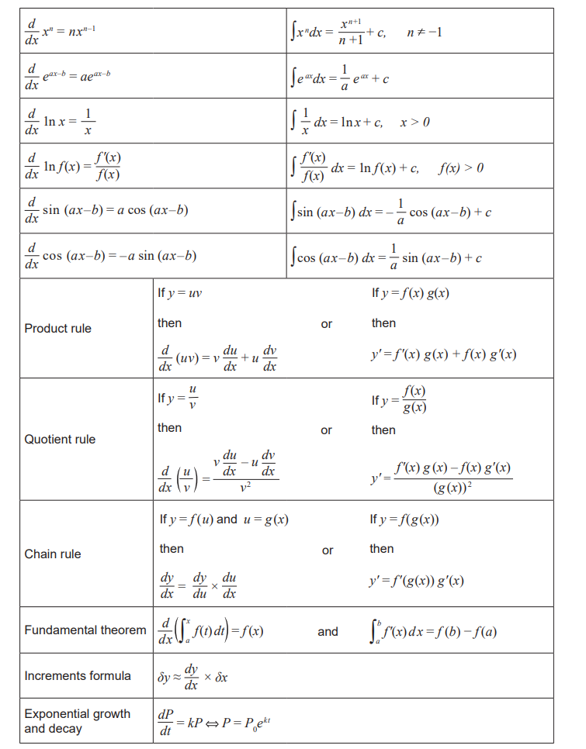

**No calculators allowed!!!**

Q1 (2 & 3 = 5 marks)

Determine the equation of the tangent to the following curves at the stated point:

1.  at the point 
2.  at the point 

Q2 (3 & 3 = 6 marks)

Determine the derivatives of the following using the quotient rule and simplify your answer.

1. 
2. 

Q3 ( 5 marks)

Determine the coordinates of the stationary points of  using calculus and justify their nature.

Q4 ( 1, 2 & 3 = 6 marks)

Consider an object initially at the origin that moves only in a straight line with displacement from origin, , given by  at time, seconds.

Determine:

1. Acceleration at  second.
2. The times the object is at rest.
3. The distance travelled in the first 3 seconds.

Q5 (2, 2 & 2 = 6 marks)

The graphs of  and  are displayed below.

|  |  |
| --- | --- |
|  |  |

1. Determine the derivative of at .
2. Determine the derivative of  at .
3. Determine the derivative of  at 

Q6 (3 marks)

If  use differentiation to determine the approximate percentage change in  when  increases

by 3%.

Q7 (5 marks)

Consider the function  as graphed below. On the axes below sketch the function  and **on this graph** label and show the coordinates and nature of all important features of .

(Do not write on original function graph)

|  |
| --- |
|  |
|  |

Q8 (4 marks)

A rectangle has one vertex at the origin, another on the positive x-axis, another on the positive y-axis and a fourth on the line  where  are constants.

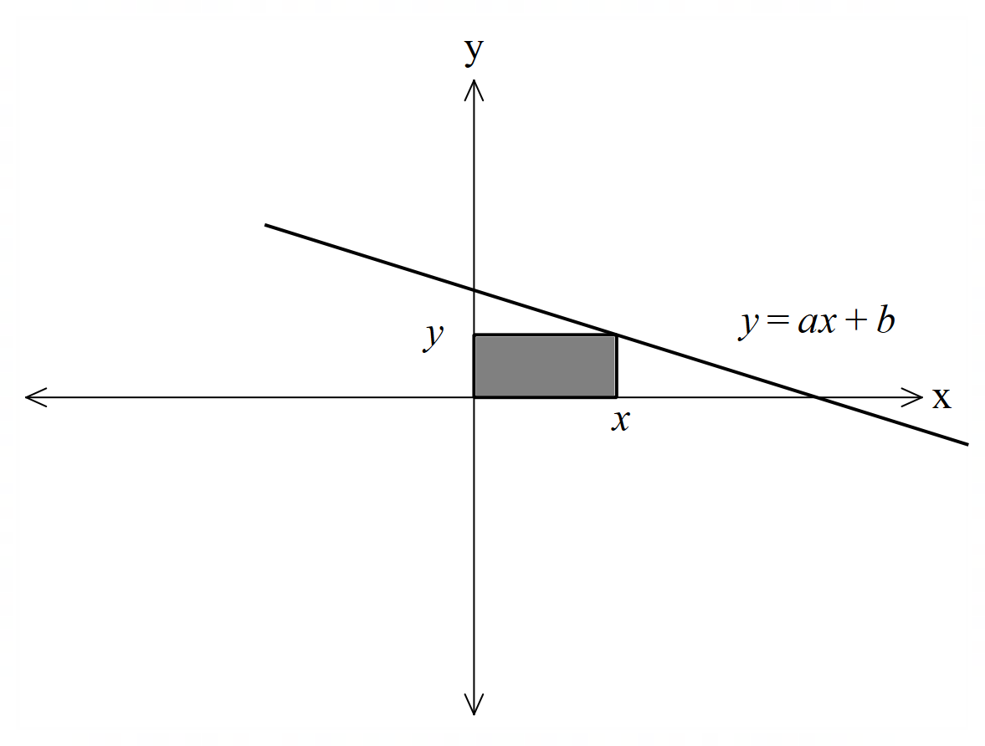

The greatest area occurs when  with an area of 32 sq units**. Using calculus**, determine the values of the constants .